Ideation Phase

Empathize & Discover
Date | 2 November 2025
Team ID | NM2025TMID08137
Project Name | Educational Organisation Using ServiceNow
Maximum Marks | 4 Marks

Empathy Map Canvas:
During the Empathize & Discover phase, the team carefully analyzed how students, faculty, and administrators engage with academic and administrative systems within an educational institution. The observations revealed that several key processes—such as admission handling, timetable management, and feedback collection—are still carried out manually or through fragmented tools, resulting in inefficiencies and delays.
Interviews and surveys further uncovered user frustrations regarding slow approvals, lack of process visibility, and communication barriers. Faculty members mentioned that tracking student progress and managing multiple tasks is often time-consuming, while students shared that accessing updates or submitting queries takes longer than expected.
These findings emphasized the urgent need for a centralized digital platform to automate workflows, unify data, and simplify communication among all stakeholders. By deeply understanding these challenges, the team designed a ServiceNow-based Educational Management System that streamlines daily operations, enhances collaboration, and enables data-informed decision-making.
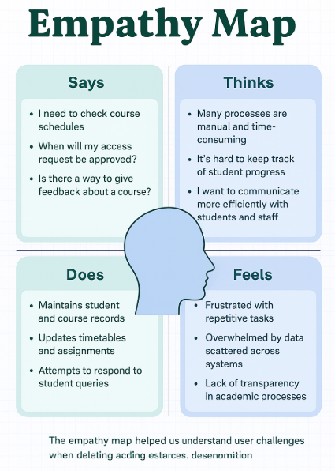
Reference: https://www.mural.co/templates/empathy-map-canvas
Insights from the Empathy Map
The empathy mapping process helped the team gain a clear picture of users’ daily experiences and struggles in managing academic and administrative work. Key pain points identified include:
- Repetitive and time-consuming manual processes
- Inefficient communication between departments
- Limited access to accurate, real-time academic information
- Difficulty in tracking workloads, feedback, and performance
By empathizing with students, faculty, and administrators, the team envisioned a digital transformation through ServiceNow. The proposed Educational Management System integrates workflow automation, digital forms, and centralized dashboards, helping institutions reduce manual effort, minimize human error, and improve coordination across all levels.
Example: ServiceNow-Based Educational Management System
Through empathy mapping, the team identified several recurring challenges across departments, including disconnected data storage, delayed approvals, and inconsistent communication.
This ensures smoother operations, improved accountability, and a more connected educational experience for everyone.
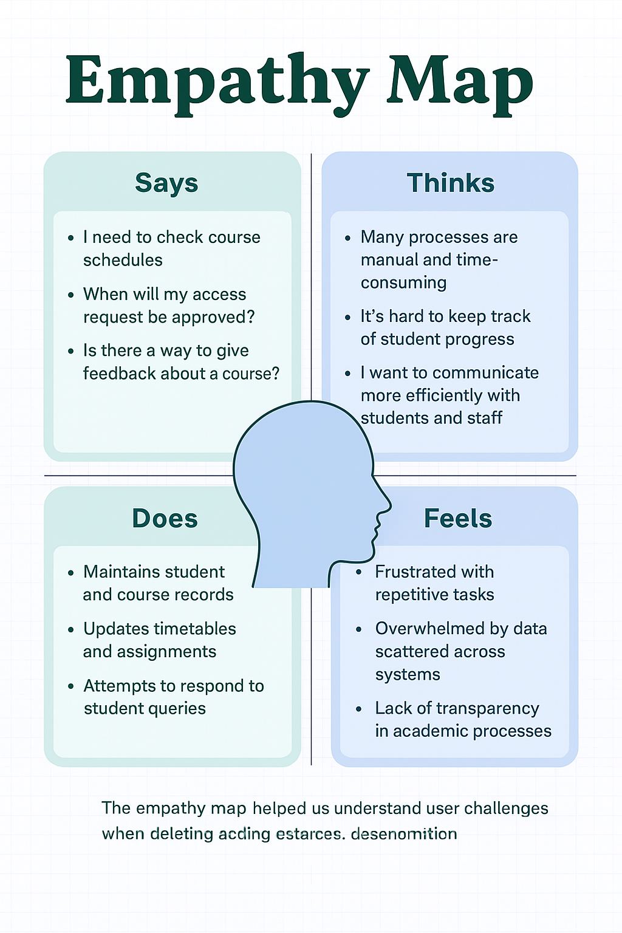
Fig: Empathy Map for Educational Organization using ServiceNow

